Transfer Learning Approach for Melanoma Skin Cancer Detection

Given Name Surname   
*dept. name of organization   
(of Affiliation)*  
*name of organization   
(of Affiliation)*City, Country  
email address or ORCID

*Abstract*—Melanoma is the deadliest kind of skin cancer, which is also the most prevalent. The key to effective therapy and better patient outcomes is early identification. Deep learning algorithms have been applied to melanoma diagnosis in recent years, and the findings are encouraging. The ResNet50 model, a popular convolutional neural network design noted for its excellent accuracy in image classification, is the one we suggest using in this paper to identify melanoma. In this paper, we present an approach to improve melanoma detection by employing preprocessing techniques and transfer learning with ResNet50 model. To enhance the quality of the dataset, we implemented several preprocessing steps. These include hair removal techniques to eliminate unwanted artifacts, as well as noise removal techniques to eliminate unwanted artifacts, as well as noise removal techniques to reduce image disturbances. Additionally, we incorporated image enhancement algorithms to further refine the dataset, resulting in improved image quality for subsequent analysis. We test our model against a 3297 dataset of skin lesion photos. Comparing its performance to that of other cutting-edge algorithms. Our findings demonstrate that the ResNet50 model surpasses competing models in terms of precision and high accuracy of 94.27% over 48 epochs making it an effective tool for the early identification of melanoma. The methodolgy of combining preprocessing techniques and transfer learning with ResNet50 model showcased the effectiveness over other methodologies.

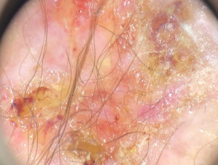 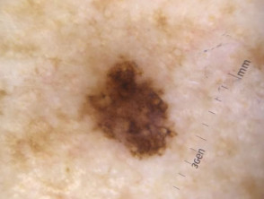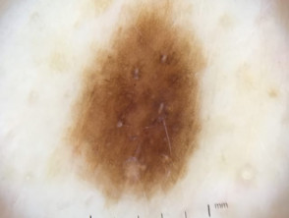 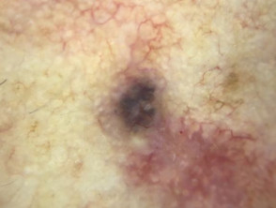

# Introduction

## Background

The epidermis, the outer layer, and the dermis, the inner layer, make up the two primary layers of the skin anatomy. The dermis, the layer underneath the epidermis, contains blood vessels, nerve endings, and other structures that sustain the skin, whereas the epidermis is the topmost layer of the skin and is responsible for defense and waterproofing. Melanocytes are found in the epidermis' bottom layer [5]. Melanin, the pigment that gives skin its natural color, is produced by melanocytes, pigment cells that are located in the bottom layer of the epidermis. Malignant skin cancer, usually referred to as melanoma, is a very aggressive and potentially fatal form of skin cancer that can quickly spread to other body parts. Melanoma can appear anywhere on the body, even in locations that are not exposed to the sun, and if it is not found and treated promptly, it can swiftly spread to other areas of the body. The Indian Journal of Dermatology reports that 59.4% of instances of melanoma are malignant. Although benign skin cancer, sometimes referred to as non-melanoma skin cancer, is a less dangerous variety of the disease, it is still a serious health problem. In the United States, non-melanoma skin cancer is projected to affect 5.4 million people annually.Fig.1 shows various types of skin cancer images. Fig.2 shows melanoma skin cancer images [3]

1. *Sample images of Skin Lesions and normal dermoscopic images*

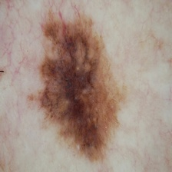 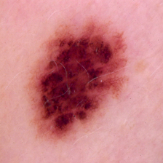

(a) (b)

1. *Melanoma (a) Malignant (b) Benign*

## Motivation

The major goal is to support initiatives to reduce the number of deaths caused by skin cancer. The project's major motivation is to use state-of-the-art picture categorization technology for human welfare. Computer vision has come a long way in the areas of machine learning and deep learning, which apply to many different fields. With the help of this research, we want to close the gap between the diagnosis and the treatment. If the project were completed with more accuracy on the dataset, the work of the dermatological clinic might be supported more efficiently. The model's improved speed and accuracy can help avoid unnecessary biopsies and aid in the early detection of melanoma.

## Research Contribution

The existing landscape of skin cancer detection has been examined using a variety of approaches, including Convolutional Neural Networks (CNNs), Support Vector Machines (SVMs), and hybrid Deep Neural Networks (DNNs). Researchers such as Masood and Al-Jumaily used partially supervised training to overcome the difficulty of minimal labeled data, attaining an accuracy of 86.5% [9]. Each technique, as demonstrated by research such as those of Albahar and Esteva, has added to our understanding of melanoma skin cancer detection, emphasizing the need for novel solutions. In this context, the suggested study adds value by presenting a transfer learning approach targeted at overcoming the limits of existing techniques. Using pre-trained models, this technology aims to improve the accuracy and efficiency of early melanoma detection. This research section presents a thorough summary of existing methodologies, their outcomes, and the innovative addition of transfer learning to the rapidly evolving field of melanoma detection.

## Organization of the article

The

# related Works

The majority of typical methodologies used for classifying skin cancer lesions were used in the literature review. Any disease diagnosis is crucial for subsequent steps and therapy. Similarly, researchers face challenges in detecting skin conditions at their early stages. The early identification of diseases poses difficulty in this domain as well. To address this issue, researchers have employed a variety of techniques to identify and diagnose various skin conditions. The following are some of these strategies. Convolutional neural networks (CNNs) were used in a system that Garg et al. proposed [8].

An approach put out by Masood and Al-Jumaily was examined using skin cancer-related datasets. However, this strategy can be evaluated and deployed in any industry where a lack of labeled data is a problem. Their research focused on partially supervised training of the algorithm utilizing unlabeled data. According to their intended investigation, 86.5% accuracy was attained [9]. Support Vector Machine (SVM) surpassed K-means clustering and Neural Network (NN) with an accuracy of 80% in the setting of melanoma skin cancer, according to Mhaske and APhalke's study [10]. The ph2 dataset was used in a study by Fidan et al., who presented a unique method for helping dermatologists identify skin lesions. Their work includes identifying abnormalities and melanoma utilizing NN and a decision support system [11].

A hybrid Deep Neural Network (DNN) was created by Amirreza and his colleagues for the classification of skin lesions. For feature generators, they employed ResNet-18, VGG16, and pre-trained AlexNet. Validation images were subjected to an SVM classifier and an accuracy of 83% was obtained for melanoma [12]. By using CNN to extract features, Rehman et al. employed an ANN classifier to identify malignant lesions in their work that was presented [13]. ABCD dermoscopy for malignancy identification employing backpropagation NN to rearrange detrimental stage was presented by Monisha et al. [14]. A method employing deep CNN and a cutting-edge regularizer technique was proposed by Albahar [15]. Jain presented research on the detection of cancerous lesions using Probabilistic Neural Network (PNN) classification [16]. Grey Level Cooccurrence Matrices (GLCMs) were employed by Maurya et al. to extract features, and multiclass SVM was then applied to obtain 81.43% accuracy [17]. Pomponiu et al. carried out a study using a clinical dataset to show how Deep Neural Networks (DNN) may be used to automatically extract features and categorize skin lesions according to their malignancy [18]. Esteva et al. revealed their findings using a single Convolutional Neural Network (CNN) on roughly 129,450 clinical images of both benign and malignant melanomas [19]. For the categorization of skin problems, another study [20] used a dataset of 19,398 images and an eight-layer CNN model on a dataset of 900 images.

To test the model, Jianfeng He et al. built a CNN model with 8 layers with a dataset of 600 images. A system for the evaluation of melanoma utilizing a CNN-based methodology was proposed by Seifedine Kadry et al. They initially extract the melanoma portion from dermoscopy images using the VGG-SegNet method. The ISIC2016 database was then used to validate the suggested technique [21]. Using the use of a comparative study method, Pham et al. [22] demonstrate how melanoma lesions can be distinguished from benign lesions by their color and shape. They use two datasets to perform data preprocessing and use six classifiers and seven feature extraction methods. They found that the Random Forest machine learning algorithm is the best classifier, with an accuracy of 81.46%. A VGG-16 modified CNN model was developed by Pai and Giridaran [23] to categorize seven types of skin lesions. It obtained an accuracy of 78% and this methodology can anticipate the skin lesions that are most likely to occur. Table 1 shows the summary of above.

|  |  |  |  |
| --- | --- | --- | --- |
| **Paper** | **Year** | **Work** | **Results** |
| [9] | 2017 | Their study concentrated on training the system using unlabeled data while just partially supervising it. | Accuracy: 86.5% |
| [10]. | 2013 | Comparison of Support Vector Machine (SVM), K-means clustering and Neural Network (NN) | Accuracy: 80%. |
| [11] | 2016 | They use NN and a decision support system to find anomalies and melanoma as part of their work. | Accuracy: 85.5%. |
| [12] | 2019 | Amirreza and his coworkers developed a hybrid Deep Neural Network (DNN) for the classification of skin lesions. They used ResNet-18, VGG16, and pre-trained AlexNet as feature generators. | Accuracy: 83%. |
| [15] | 2019 | Albahar suggested an approach utilising deep CNN and a modern regularizer methodology. | AUCROC achieved was 86.35% |
| [17] | 2014 | Maurya et al. used Grey Level Cooccurrence Matrices (GLCMs) to extract features, and multiclass SVM was used after that. | With this method, they achieve an accuracy rate of 81.43%. |
| [19] | 2017 | Using a single Convolutional Neural Network (CNN) on about 129,450 clinical images of both benign and malignant melanomas, Esteva et al. reported their findings. | Accuracy: 72.1% |
| [22] | 2019 | They perform data preparation on two datasets using six classifiers and seven feature extraction techniques. | Accuracy: 81.46% |
| [23] | 2019 | Pai and Giridaran created a VGG-16 modified CNN model to classify seven different kinds of skin lesions. | Accuracy: 78%. |
| [33] | 2023 | The study shows that the proposed methodology were the ResNet34, DenseNet121 and MobileNet-v2 as a backbone respectively in segmentation. | Accuracy: 80% |
| [34] | 2019 | The proposed architecture was validated on the ISIC2018 dataset, | Accuracy: 87.24% |
| [35] | 2023 | The proposed fully automated method integrates data gathering, model creation, and prediction stages, by combining image processing and CNN. | Accuracy: 83% |
| [36] | 2022 | Statistical analysis of two groups with a sample size of 20 each reveals | Accuracy: 94% |

1. *Related work summarization.*

# Preliminaries

## Dermatological Images

Both physicians and automated diagnostic systems require high-quality photographs of skin problems. When direct observation is not possible, dermatologists use high-resolution (HR) photographs to make the diagnosis. This is particularly prevalent in normal clinics, medical consultations, and telemedicine. On the other hand, using high-quality data has always been necessary for training trustworthy algorithms. For higher accuracy, deep learning algorithms, in particular, require a huge amount of labeled data. High-quality dermatological images are therefore essential for both clinical diagnosis and the development of novel algorithms.

The three main types of images used in the diagnosis of skin problems are clinical, dermoscopy, and histological images (Fig. 3). Mobile devices are frequently used to take clinical images for inclusion in patient records or for remote diagnostics. Images from histopathology and dermoscopy are frequently used in clinical settings to determine the extent and seriousness of various conditions.

### Clinical Images: To obtain clinical images, the area of the skin problem is shot using a camera. They serve as a patient's medical record and provide numerous insights for dermoscopy images. The fundamental issue with utilizing clinical images to classify skin cancers is that we cannot extract detailed information regarding the morphological details which also significantly affects the diagnosis process due to various imaging conditions such as zoom, angle, and contrast.

### Dermoscopy Images: Dermoscopy is an optical imaging method that involves considering pictures to study the characteristics of skin problems. Clinicians frequently use it to distinguish between benign nevus and malignant melanoma. Dermoscopy bridges the gap between clinical and Anomalous characteristics. Dermoscopy images give a detailed view of the skin's surface and enable the examination of the color and microstructure of the epidermis. For particular skin conditions, some diagnostic guidelines, including the ABCD Rule, CASH Rule, and Menzies Method [7], have been created based on dermoscopy images. However, the range of structures that can be seen in dermoscopy images for the identification of skin cancer is constrained, and the accuracy of the diagnosis might be affected by the skill of the dermatologist.

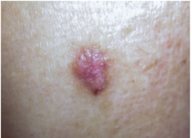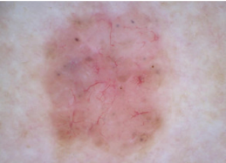(a) (b)

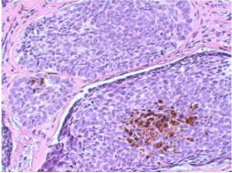  
(c)

1. *(a) Clinical image. (b) Dermoscopy image. (c) Histopathological image.*

### Histopathological Images: Microscopes were used to scan tissue slides for histopathological pictures, which were subsequently converted to digital images. They are used to display the sick tissue's vertical structure and all of its interior properties. The use of anomalous exams to identify the various cancer kinds and develop treatment regimens based on those. They are therefore frequently recognized as the standard for reference for identifying almost all types of cancers in clinical settings. Establishing a reliable pattern for diagnosis is extremely difficult because skin cancer exhibits a wide range of morphologies, scales, textures, and color distributions [7].

## Convolutional Neural Network

### Introduction: Convolutional neural networks (CNNs) are a popular and commonly utilized deep learning architecture in the area of artificial intelligence. CNNs give computers the ability to comprehend and analyze visual input, including images.

Artificial neural networks do incredibly well in machine learning. With many datasets, including those with images, audio, and text, neural networks are used. For varied tasks, multiple neural network types are used. For instance, Recurrent Neural Networks (RNNs), especially long short-term memory (LSTM) networks, are frequently utilized when predicting the word order in a sequence. On the other hand, CNNs are used for image classification tasks.

A typical neural network consists of three different types of layers

#### Input Layers: The data that is given into the neural network must be received and encoded by the input layer. Some characteristic or properties of the input image data is represented by each neuron in the input layer.

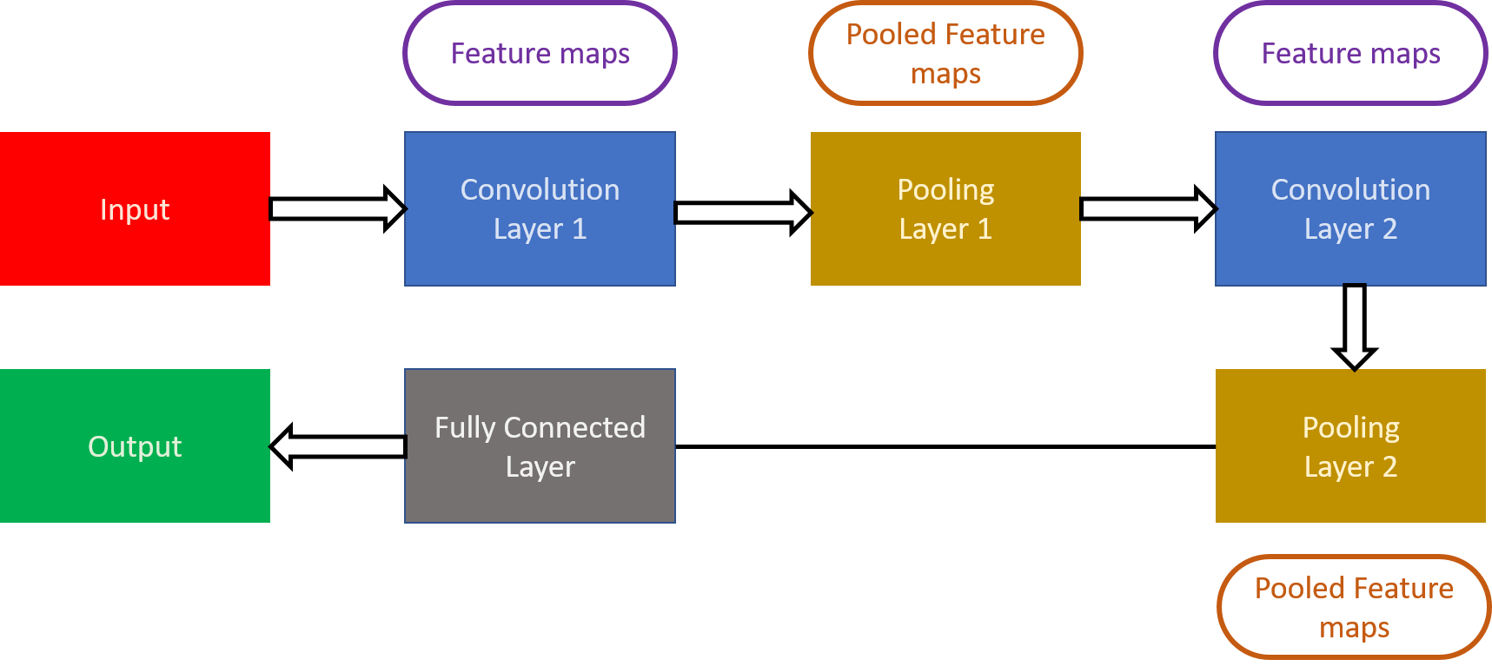

#### Hidden Layers: Between the input and output layers, there are layers called "hidden". Through a network of connected neurons, they carry out intricate calculations and transformations on the input data. A neural network may have multiple hidden layers, and these layers are in charge of extracting and learning hierarchical representations of the data.

#### Output Layer: The output layer receives the processed information from the hidden layers and produces the final output of the neural network. The number of neurons in the output layer depends on the specific task and the desired output format. For example, in a classification task, each neuron in the output layer may represent a different class label, while in a regression task, there might be a single neuron representing a continuous value.

### CNN Architecture: An input layer, an output layer, and hidden layers are all parts of a CNN's architecture. Fig. 11 shows the architecture. Convolutional, pooling, fully linked, and normalization layers are among the several kinds of layers that make up these hidden layers. The extremely effective CNN design is shown in Figure 3. The layer of input. The width, height, and depth of the input layer or volume are the measurements of the image. This dimension represents the pixel value matrix. The input, for instance, is [32x32x3]. Hence, the dimensions are 32 wide, 32 high, and 3 deep. Here, R, G, and B channels are represented by depth. The input volume of a CNN should have dimensions that are divisible by 2 multiple times.

1. *Convolutional Neural Network with its layer*

#### Convolutional Layer: Feature extraction from the input layer is the primary goal of the convolutional layer. To reduce costs, only a small portion of the image is connected to the convolutional layer. Dot products are used in all dimensions between a filter and a receptive field for this purpose. The dot product operation yields an output volume that consists of a single integer. An example of a feature map is this. The entire input image is put through this process. The output of the current layer will be used as the input for the subsequent layer. A tiny matrix called a feature detector, filter, kernel, or feature detector is used for feature detection. The usual CNN first-layer filter has a dimension of [5x5x3].

#### Pool Layer: This layer's purpose is to lessen the model's computational complexity and the spatial dimensions of the input data. This layer also controls overfitting. It is independent of the input's depth slice. The Max pool, Average pool, or L2 norm pool are examples of several functions. The most crucial component of the input layer is max pooling.

#### Fully Connected Layer: This layer's major job is to link every neuron in one layer to every other layer. The SoftMax activation function is used in this layer. The created features of the input photos are divided into distinct classes using this function. The training dataset is the foundation for this categorization.

## Transfer Learning Approach

Transfer learning is a deep learning and AI technique that uses pre-trained neural network models as a jumping-off point for tackling new problems. Transfer learning enables us to use the information gained from models that have already been trained on sizable datasets to enhance the performance of new models on smaller datasets without having to start the training process from scratch.

In transfer learning, we establish a new model for a comparable but slightly different task using the knowledge and parameters learned by a pre-trained model. For instance, a new model to classify photos of a different type can be built from scratch using a pre-trained model for image classification on a sizable dataset like ImageNet. A smaller dataset tailored to the new objective can be used to fine-tune the new model.

Transfer learning offers some advantages. Leveraging the previously learned features from the pre-trained models can save time and computational resources. Utilizing the knowledge acquired by the pre-trained models on a large dataset can also increase the new model's accuracy. When we have little data for the new job, transfer learning is very helpful because the previously trained models can serve as a solid initialization point and regularisation for the new model.

We have used the pre-trained model for skin cancer detection. By using a pre-trained model, we can leverage the knowledge learned by the model on a large dataset to improve the accuracy and efficiency of our model for the new task, especially when we have limited data available for training. Fig. 12 represents the transfer learning approach technique.

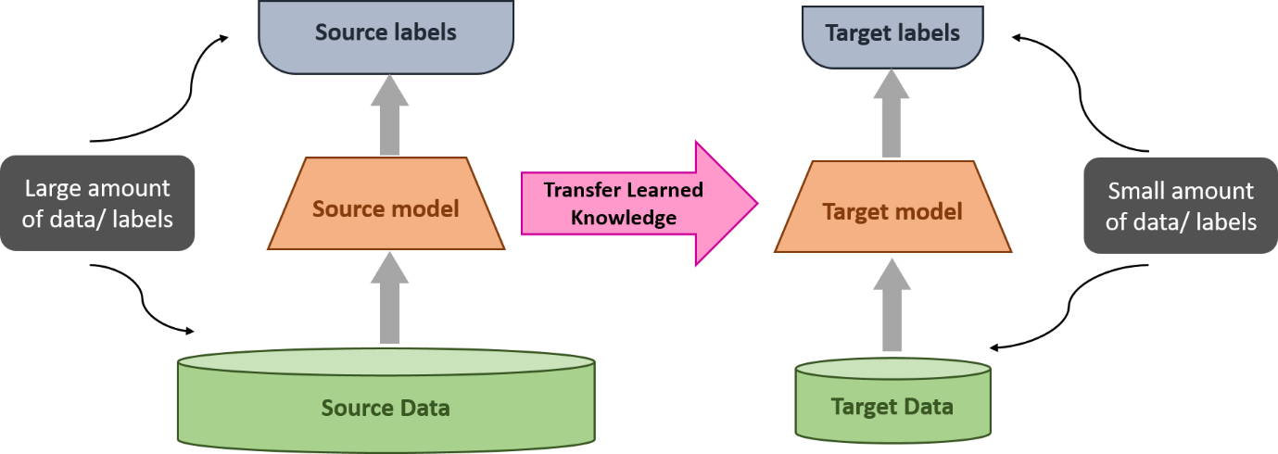

### ResNet50 Model

Incorporating the Adam optimizer in tandem with ResNet-50, a groundbreaking neural network, has proven instrumental in advancing computer vision applications. ResNet,, revolutionized deep neural networks by mitigating vanishing gradient issues, allowing for training networks exceeding 150 layers. ResNet-50, comprising 5 stages with convolution and identity blocks, addresses these challenges. The model's architecture includes three convolution layers in each identity and convolution block, totaling over 23 million trainable parameters. Adam optimizer's adaptive learning rates and momentum synergize seamlessly with ResNet-50, facilitating efficient training and convergence, establishing a robust foundation for complex image classification tasks.

#### Initial Convolution: A convolutional layer with a kernel size of 7x7 and 64 different kernels.The stride size is set to 2, resulting in the creation of 1 layer.

#### Max Pooling: After the convolutional layer, a max pooling operation is performed.The pooling operation employs a stride size of 2.

#### Convolutional Blocks: These blocks comprise multiple layers with specific kernel sizes and quantities. Each block is repeated a certain number of times to form the overall architecture.

Block 1 consists of a 1x1 convolutional layer with 64 kernels, followed by a 3x3 convolutional layer with 64 kernels, ends with a 1x1 convolutional layer with 256 kernels. This block is repeated 3 times, generating a total of 9 layers.

1. *Transfer Learning*

Block 2 comprises a 1x1 convolutional layer with 128 kernels, proceeded by a 3x3 convolutional layer with 128 kernels, concludes with a 1x1 convolutional layer with 512 kernels. This block is repeated 4 times, resulting in 12 layers.

Block 3 includes a 1x1 convolutional layer with 256 kernels, followed by two 3x3 convolutional layers with 256 kernels, ends with a 1x1 convolutional layer with 1024 kernels. This block is repeated 6 times, generating a total of 18 layers.

Block 4 consists of a 1x1 convolutional layer with 512 kernels, followed by two 3x3 convolutional layers with 512 kernels, concludes with a 1x1 convolutional layer with 2048 kernels. This block is repeated 3 times, resulting in 9 layers.

#### Average Pooling: After the convolutional blocks, an average pooling operation is performed.

#### Fully Connected Layer: The output from the average pooling layer is fed into a fully connected layer. The fully connected layer contains "n" nodes, which depend on the specific problem. A softmax function is applied at the end of this layer, yielding a single layer.

Fig. 13 depicts the basic flow diagram of the typical ResNet-50 CNN model.

1. *ResNet50 Architecture*

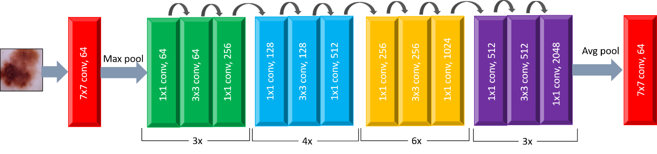

# Proposed Work

## Datasets

The International Skin Imaging Collaboration (ISIC) has provided a dataset on skin diseases available to the world's computer science community to reduce the skin cancer mortality rate and promote the development and use of digital skin imaging. More than 13,000 dermoscopic images were collected for this collection, the ISIC Archive, from clinical settings all over the world. To guarantee their quality, these photos have undergone careful expert inspection and annotation. The classification and segmentation of skin cancer cases have been the primary focus of many research projects using the ISIC dataset, with binary classification being the most often researched task.

This dataset includes a well-balanced representation of benign and malignant skin lesions. The information is split into two files, each of which contains 3297 photos (224x244) of the two distinct mole species. Our train, validation, and test folders contain two classes of images: benign and malignant. Fig. 4 shows the sample images from the dataset.

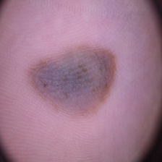 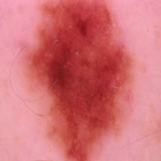

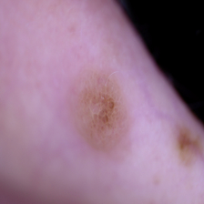 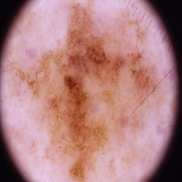

1. *Melanoma skin cancer images from the dataset.*

## Proposed Approach

Fig. 5 displays the suggested algorithm's structure as a flowchart. Getting the input image data is the first step in the procedure. High-resolution photos of skin lesions will be used as the input images for the skin cancer detection algorithm. These images can be acquired from a variety of places, like hospitals or medical databases. Pre-processing the available image dataset is the following step. To highlight the characteristics of the skin lesions, the input photos might be pre-processed. The photos can be resized to a standard size, the pixel values can be normalized, and other techniques like hair removal, noise reduction, and contrast enhancement can be used. The Dull Razor filter will be used to remove the hair. With the Median Filtering approach, the noise is reduced, and then the images are segmented. The input image is divided into smaller parts based on color, texture, or other visual signals during skin cancer image segmentation, and the regions that correlate to skin lesions are selected as regions of interest (ROIs). The following stages of skin cancer detection use these ROIs for transfer learning and classification.

The pre-trained ResNet50 model can be applied to the ROIs found in the previous phase as a feature extractor. Transfer learning can be used to replace the final few levels of the ResNet50 model with new layers that were trained on the skin cancer dataset. As a result, the model will be able to pick up on skin lesion characteristics unique to the skin cancer dataset. Once trained, the model can be used to determine if a certain skin lesion is benign or malignant to diagnose skin cancer. A probability score that indicates the possibility that the lesion is cancerous can be the projected result.

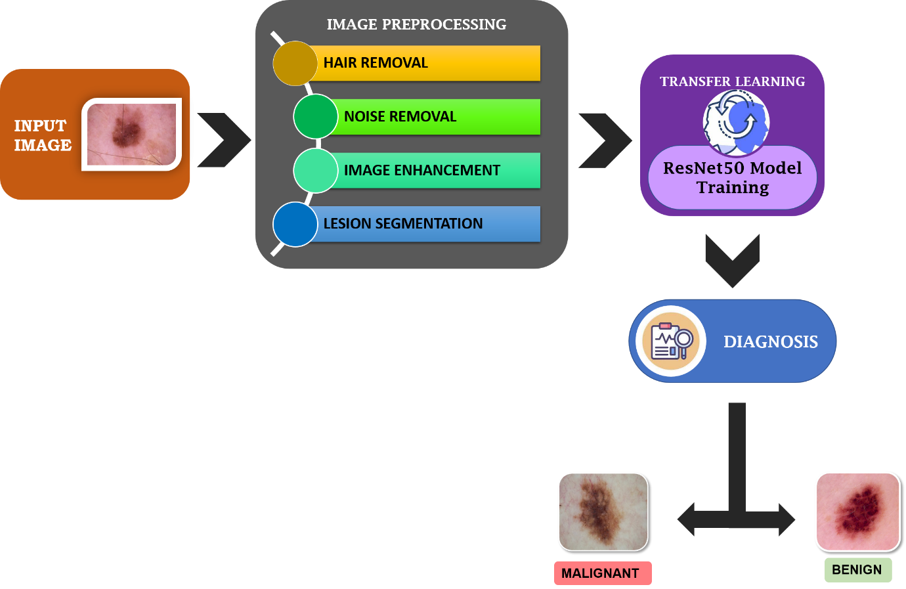

1. *The hierarchy of the proposed model.*

# Data Preprocessing

In this paper, an image passes through three stages: Pre-processing, Lesion Segmentation, and Transfer Learning—before it reaches the diagnosis step. A balanced mixture of benign and malignant skin moles is represented in this dataset. The information is divided into two folders, each containing 1800 images (224 x 244) of the two varieties of moles.

## Hair Removal

To remove hair pixels from the skin cancer images, the Dull Razor filter is used where the hair pixels (0, 0, 0) are replaced by their neighboring pixels. Fig. 6 shows the steps involved in the Removal of Hair. The result shown in Fig. 7.

**Input:** Image with hair pixels

**Output:** Image without hair pixels

1. *Steps of Dull Razor Algorithm.*

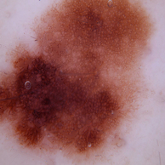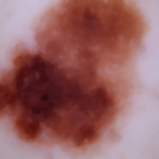

(a) (b)

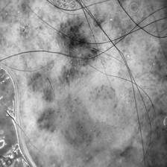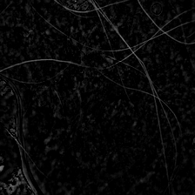

(a) (b)

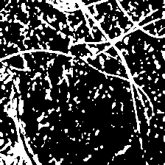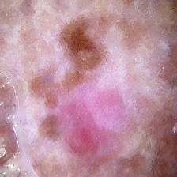

(c) (d)

1. *Dull razor steps. (a) Grayscale image. (b) Blackhat image. (c) Mask image (d) Processed image*

## Noise Removal

The noise that was created and was thereafter hair removal was removed using median filtering. To lessen noise in an image, median filtering is a nonlinear filtering technique frequently employed in digital image processing. The median filter swaps out each pixel's value for the median of the pixels around it. The edges and other details in the image are preserved while impulse noise, such as salt-and-pepper noise, is effectively removed using this filter.

Consider F (x, y) as the intensity value of the pixel located at (x, y) in the input image.

Consider G (x, y) as the intensity value of the pixel located at (x, y) in the output image after median filtering.

Let N be the size of the neighborhood used for filtering.

The median filter operation can be defined as:

G (x, y) = median {F (i, j) | i, j ∈ Ω (x, y) 

where Ω (x, y) is the N x N neighborhood centered at pixel (x, y) in the input image.

The median filter replaces the value of each pixel with the median value of its neighborhood. The median is calculated by first sorting the values in the neighborhood in ascending order and then selecting the middle value as the median. If the neighborhood size is even, then the median is the average of the two middle values.

The median filter is nonlinear because the output value at each pixel is not a linear combination of the input values in its neighborhood. It is robust to outliers and preserves edges well, making it a popular choice for removing noise in digital images. Real-time image processing systems frequently employ median filtering because it is computationally effective. Fig. 8 depicts the images with and without noise.

1. *Noise Removal. (a) Before. (b) After*

## Image Enhancement

An image processing technique called contrast enhancement of skin cancer images seeks to enhance the visual appeal and diagnostic precision of the images. Low contrast in skin cancer photos might make it challenging to discriminate between various skin lesions. By altering the image's brightness and/or contrast, contrast enhancement techniques seek to increase the perceived contrast between various sections of the image. Fig. 9 shows the enhanced part of the lesion.

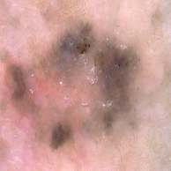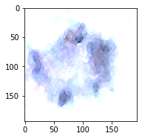

(a) (b)

1. *Image Enhancement. (a) Before. (b) After*

## Skin Lesion Segmentation

Headings Lesion segmentation is the process of locating and defining areas of interest in medical pictures, commonly referred to as lesions or abnormalities. Lesion segmentation is a crucial stage in medical image processing and is utilized in a diverse range of applications, that also include the diagnosis of diseases, the planning of treatments, and monitoring.

Lesion segmentation is a multi-step technique that includes pre-processing, feature extraction, and classification. The medical image is frequently enhanced at the pre-processing stage to enhance the elements that are of interest. This might entail actions like intensity adjustment, normalization, and picture denoising. In this instance, the image is subjected to first produce a binary image, in which the lesions stand out as white patches on a black background.

The binary image is then cleaned up by applying morphological operations like opening and closing to remove unnecessary pixels and fill in minor gaps. Erosion and dilation work together to eliminate small items and smooth the edges of bigger ones during the opening process. The closure is the result of a combination of dilatation and erosion, which fills in the object's small holes and returns it to its prior size and shape.

The lesion regions in the original color image are highlighted by a mask created from the binary image that was produced. By performing element-wise multiplication between the binary picture and the original color image, all non-lesion pixels are turned black (0,0,0), while the lesion pixels retain their original color values. The segmented image that results from adding a black backdrop and background subtraction to the image using Canny edge detection reveals just the lesion locations.

The process used here is shown in Fig. 10

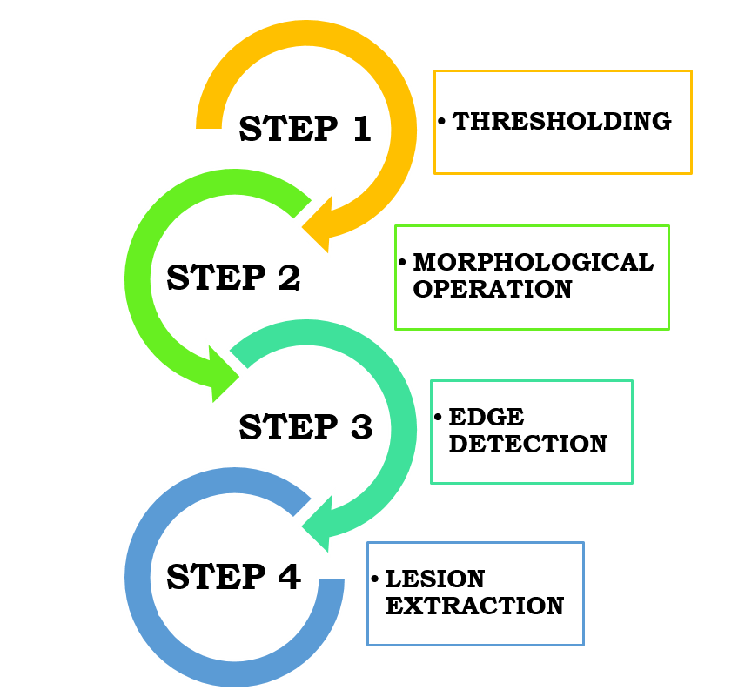

1. *Steps of Lesion Segmentation Algorithm*

Let the input image be denoted as I (x, y), where (x, y) are the spatial coordinates.

### Convert the image to grayscale:

I_gray(1x, 1y) = 0.2989 * I (x, , 0) + 0.5870 * I (x, y, 1) + 0.1140 * I (x, y, 2) 

### Smooth the image using a Gaussian filter:

𝐺 (x, y) = 1 / (2πσ²) * 𝑒𝑥𝑝 (-(x² + y²) / (2σ²)) 

### Smoothed image:

S (x, y) = I_gray (x, y) * G (x, y) 

### Calculate gradient magnitude image:

#### Sobel operator:

Gx = and

Gy =

#### Gradient magnitude:

M(X) = sqrt (Gx (x, y) ^2 + Gy (x, y) ^2) 

### Thresholding:

1. Compute the mean and standard deviation of the gradient magnitude: μ, σ
2. Threshold value:

T = μ + k * σ, where k is a constant value 

1. Threshold image:

B (x, y) = {1, M (x, y) > T; 0, M (x, y) ≤ T} 

### Morphological operations:

#### Erosion:

E (x, y) = B (x, y) ⊖ R, where R is a structuring element 

#### Dilation:

D (x, y) = E (x, y) ⊕ R 

### Connected component analysis

Label the connected components in the image. Discard the components that are too small or too large in area

### Lesion segmentation

Extract the bounding box coordinates for each connected component. Crop the original image using the bounding box coordinates to obtain the segmented lesion image

# Results & Outcomes

## Performance Evaluation

The classification of skin cancer as benign or malignant is done using pre-trained CNN ResNet50 networks on the data sets. By selecting a random skin lesion photograph, the final testing stage is completed. The accuracy and error rate are then examined. Python is used for transfer learning to identify skin cancer. RESNET 50 outperforms the other three models of four in terms of performance.

The training time was reduced by utilizing a pre-trained RESNET model and using GPU. Malignant and benign binary classifiers are used to detect skin cancer. Different epoch counts are used to identify skin cancer. More mistake probability and poorer accuracy are produced by fewer epochs and a faster learning rate.

|  |  |  |  |  |
| --- | --- | --- | --- | --- |
| **Epochs** | **Train_acc** | **Train_loss** | **Val_acc** | **Val_loss** |
| 5 | 83.88 % | 0.3463 | 83.67% | 0.2982 |
| 10 | 86.46% | 0.2939 | 83.83% | 0.2854 |
| 20 | 89.57% | 0.2349 | 87.17% | 0.2883 |
| 25 | 90.82% | 0.2059 | 88.83% | 0.2502 |
| 30 | 90.71% | 0.2289 | 90.67% | 0.2185 |
| 35 | 92.07% | 0.1820 | 90.00% | 0.2563 |
| 40 | 92.53% | 0.1842 | 91.50% | 0.2291 |
| 45 | 93.74% | 0.1597 | 90.83 % | 0.2493 |
| 48 | 94.27% | 0.1469 | 92.67% | 0.2136 |

1. *Accuracy and loss for different counts of epochs*

Table 2 lists the number of epochs given and the accompanying output for training ResNet50 with a different count. It is investigated how much accuracy is lost when examining different image sets for train and validation. Low accuracy and substantial validation loss were the outcomes.

Many data sets were employed during the training procedure to increase the system's accuracy. Further training using the data set results in an accuracy improvement of roughly 94.27% over 48 epochs.

## Comparative Analysis

# Conclusion

This paper proposes a novel strategy to melanoma detection that combines preprocessing approaches and transfer learning using the ResNet50 model. Hair removal, noise reduction, and picture enhancement were used to considerably increase dataset quality, resulting in a remarkable accuracy of 94.27% over 48 epochs. This outperforms the performance of current algorithms, confirming the ResNet50 model's efficacy in detecting early melanoma.

This study's contributions are in the improved detection capabilities acquired through the integration of preprocessing approaches with transfer learning. By addressing issues such as undesired artifacts and visual disruptions, the ResNet50 model displayed better accuracy, demonstrating its promise as a reliable tool for skin cancer diagnosis. Future research should focus on testing the concept in a variety of clinical contexts and evaluating its efficacy in bigger patient populations. Furthermore, more research into multispectral imaging and machine learning applications can help to develop this approach, perhaps paving the way for non-invasive, low-cost, and accurate skin cancer screening on a larger scale. Investing in such technology has the potential to improve not only patient outcomes but also the cost burden associated with advanced-stage therapies, underscoring the importance of early identification in skin cancer care.

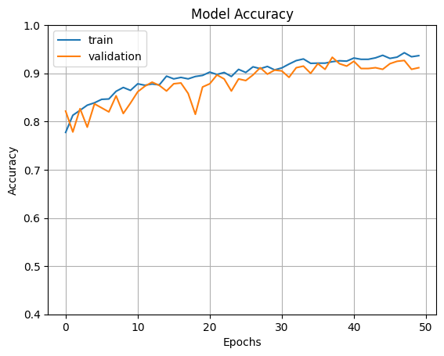

s

1. *Accuracy and Loss on Training and Validation Data.*

##### References

1. Apalla Z, Nashan D, Weller RB, Castellsagué X. Skin Cancer: Epidemiology, Disease Burden, Pathophysiology, Diagnosis, and Therapeutic Approaches. Dermatol Ther (Heidelb). 2017 Jan;7(Suppl 1):5-19. doi: 10.1007/s13555-016-0165-y. Epub 2017 Feb 1. PMID: 28150105; PMCID: PMC5289116.
2. S. Sasikala, S. Arun Kumar, S.N. Shivappriya and Priyadharshini Towards Improving Skin Cancer Detection Using Transfer LearningNAAS Journal Score 2020 (4.31) SJIF: 2020 (7.728) A Society of Science and Nature Publication, Bhopal India 2020. All rights reserved. <http://dx.doi.org/10.21786/bbrc/13.11/13>
3. Preeti Gupta,Sachin Meshram, "SKIN LESION DETECTION USING VGG-16 AND RESNET-50 BASED HYBRID CNN MODEL", International Journal of Creative Research Thoughts (IJCRT), ISSN:2320-2882, Volume.10, Issue 6, pp.f934-f941, June 2022, Available at :http://www.ijcrt.org/papers/IJCRT22A6730.pdf
4. Abbas, Q., Ramzan, F. & Ghani, M.U. Acral melanoma detection using dermoscopic images and convolutional neural networks. Vis. Comput. Ind. Biomed. Art 4, 25 (2021). <https://doi.org/10.1186/s42492-021-00091-z>
5. Abbas Hanon. Alasadi, Baidaa M. ALsafy,"Early Detection and Classification of Melanoma Skin Cancer", International Journal of Information Technology and Computer Science(IJITCS), vol.7, no.12, pp.67-74, 2015. DOI: 10.5815/ijitcs.2015.12.08
6. Phan T-D-T, Kim S-H, Yang H-J, Lee G-S. Skin Lesion Segmentation by U-Net with Adaptive Skip Connection and Structural Awareness. Applied Sciences. 2021; 11(10):4528. <https://doi.org/10.3390/app11104528>
7. Wu Y, Chen B, Zeng A, Pan D, Wang R and Zhao S (2022) Skin Cancer Classification with Deep Learning: A Systematic Review. Front. Oncol. 12:893972. doi: 10.3389/fonc.2022.893972
8. Garg R., Maheshwari S., Shukla A. Innovations in Computational Intelligence and Computer Vision. Berlin, Germany: Springer; 2021. Decision support system for detection and classification of skin cancer using CNN; pp. 578–586.
9. Masood A., Al-Jumaily A. Semi advised learning and classification algorithm for partially labeled skin cancer data analysis. Proceedings of the 2017 12th International Conference on Intelligent Systems and Knowledge Engineering (ISKE); November2017; Nanjing, China. IEEE; pp. 1–4.
10. Mhaske H. R., Phalke D. A. Melanoma skin cancer detection and classification based on supervised and unsupervised learning. Proceedings of the 2013 International conference on Circuits, Controls and Communications (CCUBE); December 2013; Bengaluru, India. pp. 1–5.
11. Fidan U., Sari I., Kumrular R. K. Classification of skin lesions using ANN. Proceedings of the 2016 Medical Technologies National Congress (TIPTEKNO); October 2016; Antalya, Turkey. pp. 1–4.
12. Mahbod A., Schaefer G., Wang C., Ecker R., Ellinge I. Skin lesion classification using hybrid deep neural networks. Proceedings of the 2019 IEEE International Conference on Acoustics, Speech and Signal Processing (ICASSP); May 2019; Brighton, UK. pp. 1229–1233.
13. Rehman M. U., Khan S. H., Danish Rizvi S. M., Abbas Z., Zafar A. Classification of skin lesion by interference of segmentation and convolotion neural network. Proceedings of the 2018 2nd International Conference on Engineering Innovation (ICEI); July 2018; Bangkok, Thailand. pp. 81–85.
14. Monisha M., Suresh A., Bapu B. R. T., Rashmi M. R. Classification of malignant melanoma and benign skin lesion by using back propagation neural network and ABCD rule. Cluster Computing. 2019;22(S5):12897–12907. doi: 10.1007/s10586-018-1798-7.
15. Albahar M. A. Skin lesion classification using convolutional neural network with novel regularizer. IEEE Access. 2019; 7:38306–38313. doi: 10.1109/ACCESS.2019.2906241.
16. Jain Y. K., Jain M. Skin cancer detection and classification using wavelet transform and probabilistic neural network. Proceedings of the 4th International Conference on Advances in Recent Technologies in Communication and Computing (ARTCom2012); October 2012; Bangalore, India. pp. 250–252.
17. Maurya R., Surya Kant Singh S. K., Maurya A. K., Kumar A. GLCM and multi class support vector machine based automated skin cancer classification. Proceedings of the 2014 International Conference on Computing for Sustainable Global Development (INDIACom); March 2014; New Delhi, India. pp. 444–447.
18. Pomponiu V., Nejati H., Cheung N.-M. Deepmole: deep neural networks for skin mole lesion classification. Proceedings of the 2016 IEEE International Conference on Image Processing (ICIP); September 2016; Phoenix, AZ, USA. pp. 2623–2627.
19. Esteva A., Kuprel B., Novoa R. A., et al. Dermatologist-level classification of skin cancer with deep neural networks nature 2017;542(7639):115–118. doi: 10.1038/nature21056.
20. Binczyk F., Prazuch W., Bozek P., Polanska J. Radiomics and artificial intelligence in lung cancer screening. *Translational Lung Cancer Research .*2021;10(2):1186–1199. doi: 10.21037/tlcr-20-708. [[PMC free article](https://www.ncbi.nlm.nih.gov/pmc/articles/PMC7947422/)] [[PubMed](https://pubmed.ncbi.nlm.nih.gov/33718055)] [[CrossRef](https://doi.org/10.21037%2Ftlcr-20-708)] [[Google Scholar](https://scholar.google.com/scholar_lookup?journal=Translational+Lung+Cancer+Research&title=Radiomics+and+artificial+intelligence+in+lung+cancer+screening&author=F.+Binczyk&author=W.+Prazuch&author=P.+Bozek&author=J.+Polanska&volume=10&issue=2&publication_year=2021&pages=1186-1199&pmid=33718055&doi=10.21037/tlcr-20-708&)]
21. Kadry S., Taniar D., Damasevicius R., Rajinikanth V., Lawal I. A. Extraction of abnormal skin lesion from dermoscopy image using VGG-SegNet. Proceedings of the 2021 7th International conference on Bio Signals, Images, and Instrumentation (ICBSII); March 2021; Chennai, India. p. p. 1. [[CrossRef](https://doi.org/10.1109%2FICBSII51839.2021.9445180)] [[Google Scholar](https://scholar.google.com/scholar?q=Kadry+S.+Taniar+D.+Damasevicius+R.+Rajinikanth+V.+Lawal+I.+A.+Extraction+of+abnormal+skin+lesion+from+dermoscopy+image+using+VGG-SegNet+Proceedings+of+the+2021+7th+International+conference+on+Bio+Signals,+Images,+and+Instrumentation+(ICBSII)+March+2021+Chennai,+India+p.+1+10.1109/ICBSII51839.2021.9445180+)]
22. Pham T. C., Tran G. S., Nghiem T. P., Doucet A., Luong C. M., Hoang V.-D. A comparative study for classification of skin cancer. Proceedings of the 2019 International Conference on System Science and Engineering (ICSSE); July 2019; Dong Hoi, Vietnam. [[CrossRef](https://doi.org/10.1109%2FICSSE.2019.8823124)] [[Google Scholar](https://scholar.google.com/scholar?q=Pham+T.+C.+Tran+G.+S.+Nghiem+T.+P.+Doucet+A.+Luong+C.+M.+Hoang+V.-D.+A+comparative+study+for+classification+of+skin+cancer+Proceedings+of+the+2019+International+Conference+on+System+Science+and+Engineering+(ICSSE)+July+2019+Dong+Hoi,+Vietnam+10.1109/ICSSE.2019.8823124+2-s2.0-85072929094+)]
23. Pai K., Giridharan A. Convolutional Neural Networks for classifying skin lesions. Proceedings of the TENCON 2019 - 2019 IEEE Region 10 Conference (TENCON); October 2019; Kochi, India. pp. 1794–1796. [[CrossRef](https://doi.org/10.1109%2FTENCON.2019.8929461)] [[Google Scholar](https://scholar.google.com/scholar?q=Pai+K.+Giridharan+A.+Convolutional+Neural+Networks+for+classifying+skin+lesions+Proceedings+of+the+TENCON+2019+-+2019+IEEE+Region+10+Conference+(TENCON)+October+2019+Kochi,+India+1794+1796+10.1109/TENCON.2019.8929461+)]
24. Riker AI, Zea N, Trinh T. The epidemiology, prevention, and detection of melanoma. Ochsner J. 2010 Summer;10(2):56-65. PMID: 21603359; PMCID: PMC3096196.
25. T y, Satheesha & Satyanarayana, D. & Giriprasad, M.N.. (2014). A Pixel Interpolation Technique for curved hair removal in skin images to support melanoma detection. Journal of Theoretical and Applied Information Technology. 70. 559-565.
26. Mohammad Saber Iraji,Azam Tosinia,"Skin Color Segmentation in YCBCR Color Space with Adaptive Fuzzy Neural Network (Anfis)",IJIGSP,vol.4,no.4,pp.35-41,2012.
27. Kato, J.; Horimoto, K.; Sato, S.; Minowa, T.; Uhara, H. Dermoscopy of melanoma and non-melanoma skin cancers. Front. Med.2019, 6, 180. [CrossRef]
28. Fujisawa, Y.; Inoue, S.; Nakamura, Y. The possibility of deep learning-based, computer-aided skin tumor classifiers. Front. Med.2019, 6, 191.
29. Fujisawa, Y.; Inoue, S.; Nakamura, Y. The possibility of deep learning-based, computer-aided skin tumor classifiers. Front. Med.2019, 6, 191.
30. K. M. Hosny, M. A. Kassem and M. M. Foaud, "Skin Cancer Classification using Deep Learning and Transfer Learning," 2018 9th Cairo International Biomedical Engineering Conference (CIBEC), Cairo, Egypt, 2018, pp. 90-93, doi: 10.1109/CIBEC.2018.8641762.
31. Tembhurne, J.V., Hebbar, N., Patil, H.Y. et al. Skin cancer detection using ensemble of machine learning and deep learning techniques. Multimed Tools Appl 82, 27501–27524 (2023). https://doi.org/10.1007/s11042-023-14697-3
32. Viknesh, C.K.; Kumar, P.N.; Seetharaman, R.; Anitha, D. Detection and Classification of Melanoma Skin Cancer Using Image Processing Technique. Diagnostics 2023, 13, 3313. <https://doi.org/10.3390/diagnostics13213313>
33. S., Kavitha & Shalini, R & Akash, J. (2023). Intelligant Segmentation and Classification for Skin Cancer Prediction. 1-6. 10.1109/ICAECA56562.2023.10200284.
34. H. Kassani, Sara & Hosseinzadeh Kassani, Peyman & Wesolowski, Mike & Schneider, Kevin & Deters, Ralph. (2019). Depthwise Separable Convolutional Neural Network for Skin Lesion Classification. 10.1109/ISSPIT47144.2019.9001790.
35. SRIVASTAV, S.; GULERIA, K.; SHARMA, S. Skin Cancer Classification using Deep Learning based Convolutional Neural Network Model. 2023 IEEE Renewable Energy and Sustainable E-Mobility Conference (RESEM), Renewable Energy and Sustainable E-Mobility Conference (RESEM), 2023 IEEE, [s. l.], p. 1–5, 2023. DOI 10.1109/RESEM57584.2023.10236339.
36. S. Likhitha and R. Baskar, "Skin Cancer Classification using CNN in Comparison with Support Vector Machine for Better Accuracy," 2022 11th International Conference on System Modeling & Advancement in Research Trends (SMART), Moradabad, India, 2022, pp. 1298-1302, doi: 10.1109/SMART55829.2022.10047280.